Title: | Door Control Module  Adc SWC

History
Issue status  (Index) | Maturity/Date  (draft/invalid/valid)  (dd-mmm-yyyy) | Author  Department | Check/Release  Department | Description
1.0 | Draft  04-0ct-20 | Miguel Garcia | Miguel Garcia | Creation of the document

Table of Contents
1 Purpose 3
2 Definitions and abbreviations 3
3 Realization constraints and targets 3
4 SW Conceptual design 3
5 SW Component internal breakdown 4
5.1 Functional Decomposition 4
5.2 Function <Type> <function name> (type par 1, .., type par n) 5
5.3 Function <Type> <function name> (type par 1, .., type par n) 5

Purpose
This document describes Adc SWC strategy used to provide measured values from analog signals.

Definitions and abbreviations
Definitions
Special Byte | Special byte received to change the baud rate 55h
Adc | Analog digital converter
SWC | Software Component

Abbreviations
Only SW Component specific abbreviations.
References
N° | Document name | Reference
1 | SW Architecture description

Realization constraints and targets

SW Conceptual design
To make a conceptual design identify the product functions and the programs parts needed to produce them.
- Identify all relevant parts in a system or sub-system.
- Define which parts are inside & outside the system boundary
- Define de interfaces between these parts, but also interfaces with neighboring systems and environment.
- Describe the global data and the interfaces in order to interact with it.

SW Component internal breakdown
N/A

Functional Decomposition
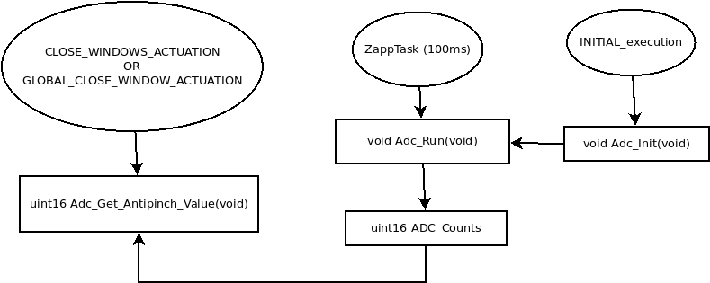
Overview of functions and their dependencies shown by a Static Function Tree
Function Description and Dynamic Behavior
Provide detailed static and dynamic description of all functions of the SW Component.
Functions which are defined in other SW Components shall only be referenced in the external interface description!
The signature description shall be done inside the function header in the source code.

Function - extern uint16 Adc_Get_AntiPinch_Value (void)

Description | Adc Interface to report measured value of the AntiPinch signal.
Parameter | N/A
Return Value | This function returns value from static variable ADC_Counts
Precondition | This function must be called by either CLOSE_WINDOWS_ACTUATION or GLOBAL_CLOSE_WINDOW_ACTUATION.
Post condition | N/A
Error Conditions
Requirements | DCU_SWR_108

Function - extern void Adc_Init (void)
Description | Interface function to perform Adc SWC initialization.
Parameter | N/A
Return Value | N/A
Precondition | This function must be called after ECU reset.
Post condition | N/A
Error Conditions
Requirements | DCU_SWR_108

Dynamic Behavior
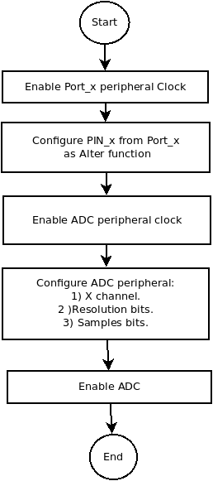

Function – extern void Adc_Run (void)
Description | Interface function to perform Adc SWC Periodic Operations.
Parameter | N/A
Return Value | N/A
Precondition | Adc must be initialized by calling Adc_Init().
Post condition | N/A
Error Conditions
Requirements | DCU_SWR_108

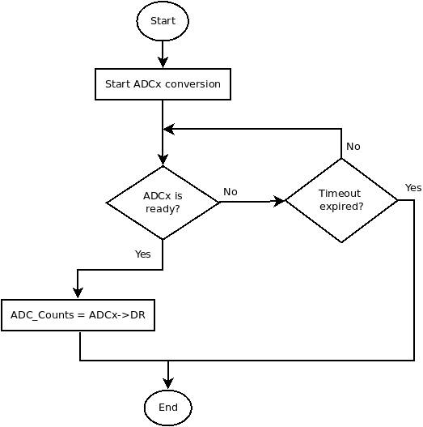
Dynamic Behavior

